**Chapter 1**

**INTRODUCTION**

* 1. **OVERVIEW:**

A blood bank information system is a software application that manages the information related to blood donation and storage. It is an essential tool for blood banks and hospitals to keep track of blood donation, storage, and distribution. The system stores and manages the donor's information, blood type, and the availability of blood units. It also manages the requests for blood from hospitals and clinics.

The primary goal of the blood bank information system is to provide an efficient and effective way of managing blood donation and storage. The system helps to ensure that the blood bank has enough blood units available to meet the needs of patients. It allows the blood bank staff to manage and track the blood units from the time they are donated to the time they are issued to a patient.

The blood bank information system is comprised of several modules that work together to provide a comprehensive solution. The home module serves as the main home of the system, providing access to all other modules. The search module allows users to search for specific information about donors, blood types, and blood units. The insert data module allows the staff to add new donors and blood units to the system. The update data module allows the staff to update the information related to donors and blood units. The delete data module allows the staff to remove donors and blood units from the system.

One of the critical features of the blood bank information system is the ability to manage blood inventory levels. The system can generate alerts when the blood inventory level is low, allowing the staff to take the necessary steps to replenish the stock. The system also tracks the expiry dates of blood units, ensuring that expired blood is not used for transfusion.

The blood bank information system improves the efficiency and effectiveness of blood banks by reducing manual processes and improving accuracy. It also provides real-time access to critical information, making it easier for staff to make informed decisions. The system also ensures compliance with regulatory requirements, such as maintaining records of blood donations and transfusions.

In conclusion, the blood bank information system is an essential tool for blood banks and hospitals to manage blood donation and storage. The system provides a comprehensive solution for managing blood inventory, donors, and blood units. It helps to improve efficiency, accuracy, and compliance with regulatory requirements. With the blood bank information system, blood banks and hospitals can ensure that they have enough blood units to meet the needs of patients.

* 1. **THESIS ORGANIZATION:**

Following is a brief introduction to the chapters discussed in this report:

**Chapter 1 titled as *Introduction*** gives overview of different search techniques, Aims, Research Background.

**Chapter 2 titled as *Literature Review*,** summarizes the existing system which were referred for research development. Most blood bank management systems work only for regular blood groups, not for special blood groups like ‘HH’; most don’t have a centralized form of system. Some of their work is only for donors and some only for blood banks but a blood unit have major three resources donors, blood banks, and hospitals. So it is necessary to make a system that combines all these three units into a system and create a database that has a record of all blood units in hospitals, blood banks, and as well as all donors who want to donate blood.

**Chapter 3 titled as *Problem Statement*,** This chapter deals with analysis and designing of existing system. The problem is defined and its sub-objectives are list in this chapter. The feasibility study is done if the system stands feasible on the expected input and provides satisfactory output. The hardware and software are listed under this chapter.

**Chapter 4 titled as *Objective and Motivation*,** This chapter deals with the objectives and motivation to implement for this work.

**Chapter 5 titled as *System Analysis and Design*,** system design and implementation is thoroughly discussed under this chapter. Proposed System Architecture, DFD and component structure are detailed along with the techniques employed to get the output. The algorithm and methods are also detailed here

**Chapter 6 titled as *System Implementation,*** includes System Configuration & Environment and System Execution Details.

**Chapter 7 titled as *Conclusion,*** The conclusion of this system are discussed under this chapter summarizing the entire project in brief.

**Chapter 8 titled as *Future Scope*,** The future scope of this system are discussed under this chapter summarizing the entire project in brief with itsits future implications and advancements.

**Chapter 2**

**LITERATURE REVIEW**

* 1. **EXISTING SYSTEM:**

The existing blood bank information system is primarily a manual system that involves paper-based documentation and record-keeping. This traditional method of storing and retrieving information is prone to errors, and often results in a time-consuming and labor-intensive process. Additionally, the manual system lacks the ability to provide real-time information, which can be critical in emergencies.

The current system involves maintaining a register of donors, their blood groups, and their contact information. When a request for blood is received, the staff manually checks the register to find a matching donor. This process can be time-consuming and inefficient, particularly during emergencies. The manual system also makes it difficult to track inventory levels, leading to instances of stock outs and wastage.

The existing system also lacks a centralized database, making it challenging to maintain and retrieve donor and patient records. This can result in errors, duplication of effort, and difficulty in tracking donor and patient history.

Another significant challenge faced by the current system is maintaining the confidentiality and security of sensitive donor and patient information. With the manual system, it is difficult to control access to sensitive information, making it vulnerable to misuse and theft.

Overall, the current blood bank information system is outdated and inefficient, leading to suboptimal outcomes for donors and patients. The need for a more modern and efficient system is critical to ensure timely and accurate information management, streamlined processes, and enhanced donor and patient care.

* 1. **BENEFITS OF BLOOD BANK INFORMATION SYSTEM:**

The implementation of a Blood Bank Information System (BBIS) provides various benefits to both blood banks and their users. Firstly, BBIS ensures proper management of the entire blood donation process by maintaining accurate records of donor information, blood type, quantity, and inventory status. This enables blood banks to better manage their inventory and avoid shortages, ensuring that patients have access to the blood they need when they need it.

Secondly, BBIS provides a platform for communication between blood banks and hospitals/healthcare facilities, enabling quick and efficient blood transfer to patients in need. BBIS allows healthcare facilities to easily search for and request blood units from blood banks, which can be quickly identified and allocated based on matching blood type and availability.

Thirdly, BBIS reduces the risk of transfusion errors by accurately identifying the donor and matching the blood type to the recipient. This can significantly reduce the risk of complications and negative reactions to blood transfusions.

Fourthly, BBIS helps to maintain the confidentiality and privacy of donor information by providing secure and centralized storage of donor records. This ensures that sensitive information is only accessible by authorized personnel and is protected from unauthorized access or disclosure.

Finally, BBIS provides real-time access to accurate blood inventory data, enabling blood banks to make informed decisions about blood collection, storage, and allocation. This improves the efficiency of blood bank operations and helps to reduce waste, as expired or unused blood units can be quickly identified and removed from inventory.

Overall, the implementation of a BBIS can improve the quality and safety of blood transfusions, reduce waste, and enhance the efficiency of blood bank operations.

* 1. **TECHNOLOGY COMPONENTS OF BLOOD BANK INFORMATION SYSTEM:**

The Blood Bank Information System is developed using VB 6.0 technology and MS Access database technology. VB 6.0 is a popular object-oriented programming language widely used for developing desktop applications. It offers a rich set of features and capabilities, including a user-friendly interface, drag-and-drop functionality, and easy integration with other technologies. With VB 6.0, developers can quickly create applications with a high level of functionality and performance.

MS Access is a database management system developed by Microsoft. It is a relational database that provides a user-friendly interface for managing and querying data. MS Access is widely used for developing small to medium-sized database applications. It offers a variety of features, including data import/export, reporting, and query functionality. MS Access also supports SQL, which allows for more complex queries and data manipulation.

The Blood Bank Information System uses MS Access as its database technology to store and manage all the data related to the blood bank. It includes information about donors, blood groups, units of blood available, and other relevant data. The system uses VB 6.0 technology to provide a user-friendly interface that allows users to easily navigate the system and perform various functions such as searching for blood units, adding new donors, updating donor information, and deleting donor records.

The system also includes various forms and reports that provide valuable insights into the blood bank operations. These reports can help blood bank managers and administrators to analyze the data and make informed decisions about inventory management, donor recruitment, and other key aspects of blood bank operations.

Overall, the use of VB 6.0 and MS Access in the Blood Bank Information System ensures a reliable, scalable, and user-friendly solution for managing the blood bank's data and operations.

**Chapter 3**

**PROBLEM STATEMENT**

**3.1 PROBLEM STATEMENT:**

Blood donation is an essential and crucial aspect of healthcare that helps save millions of lives every year. However, managing blood donation activities and maintaining a database of donors and recipients can be challenging without proper technology and systems in place. Blood banks often face difficulties in managing their inventory of blood products, ensuring the safety and quality of donated blood, and keeping track of donors and recipients.

One of the major issues with existing blood bank systems is the lack of a centralized database, which makes it difficult to share information between different blood banks and hospitals. Additionally, the manual entry of data and outdated technology used by some blood banks can lead to errors and inefficiencies in managing the blood donation process.

Another problem is the lack of proper communication between blood banks and hospitals. In many cases, hospitals are not aware of the availability of specific blood types in nearby blood banks, which can cause delays and inconvenience for patients who urgently require blood transfusions.

Moreover, there are issues related to maintaining the confidentiality of donor information and ensuring that the donated blood is safe and of high quality. Without proper checks and balances, there is a risk of contaminated blood entering the supply chain and causing harm to patients.

To address these issues, a blood bank information system is needed that can provide a centralized database for blood banks, streamline the donation process, and facilitate communication between blood banks and hospitals. This system should be user-friendly, secure, and efficient, allowing for easy data entry and retrieval and ensuring that all relevant parties have access to the necessary information.

**Chapter 4**

**OBJECTIVE & MOTIVATION**

**4.1 OBJECTIVE:**

The objective of the blood bank information system is to create a comprehensive and efficient system for managing blood donation and transfusion processes. The system aims to provide a centralized platform that stores, processes, and retrieves data related to blood donors, recipients, and inventory. It facilitates the timely and accurate tracking of blood donations and usage, ensuring that the right blood type is available when needed.

The system will automate many manual processes associated with blood bank management, such as record keeping, scheduling blood drives, and tracking donor eligibility. By automating these processes, the system will reduce errors and improve the speed and accuracy of blood bank operations.

**4.2 MOTIVATION:**

Blood transfusion is a life-saving medical procedure that requires the timely availability of safe and compatible blood. However, managing blood donation and transfusion processes can be challenging, especially in large hospitals and blood banks where a significant volume of blood is needed every day. Manual record-keeping and tracking of blood donations and inventory can lead to errors, delays, and even jeopardize patient safety.

The motivation behind the blood bank information system is to improve the efficiency and safety of blood donation and transfusion processes and to get the patient and to make the blood available specially for emergency patient. By automating many of the manual processes associated with blood bank management, the system will reduce the risk of errors and ensure that the right blood type is available when needed.

Moreover, the system will provide easy access to donor information, making it easier for hospitals to organize blood drives and coordinate with donors. The system will also improve the management of blood inventory by tracking expiration dates and minimizing wastage.

**Chapter 5**

**SYSTEM ANALYSIS AND DESIGN**

**5.1 SYSTEM ANALYSIS AND DESIGN:**

System analysis and design is the process of studying, analyzing, and designing information systems to improve business operations and achieve organizational goals. The main objective of system analysis and design is to develop a system that is efficient, effective, and user-friendly.

The process of system analysis involves studying and understanding the existing system, identifying problems, and proposing solutions to those problems. The system design process involves developing a new system based on the proposed solutions.

The first step in system analysis and design is to identify the requirements of the new system. This includes identifying the data and processes involved in the system, as well as the system's user requirements. Once the requirements have been identified, the system design process begins. During this phase, the system is designed based on the requirements identified in the analysis phase. This includes developing a system architecture, designing the database structure, and creating user interfaces.

The system analysis and design process also includes testing and implementation of the new system. Testing involves verifying that the new system meets the user requirements and operates as expected. Implementation involves installing the new system, training users on how to use it, and providing ongoing support.

Overall, the system analysis and design process is critical to the success of any information system. It ensures that the new system meets the user's requirements and improves the organization's operations. By following a structured system analysis and design methodology, the development of the blood bank information system can be carried out in a systematic and efficient manner.

**5.2 SYSTEM OBJECTIVE:**

The system objectives of a blood bank information system are the specific goals that the system intends to achieve. The primary objective of a blood bank information system is to efficiently manage and maintain the blood inventory, donors' information, and blood requests.

Some specific objectives of the system are:

1. Efficient Management of Blood Donors: The system should be able to maintain a database of blood donors and their relevant details such as name, contact number, blood group, medical history, and other relevant information.
2. Proper Blood Inventory Management: The system should be capable of managing the blood inventory by keeping track of the available stock, blood type, and expiration dates. The system should also generate alerts when the inventory is running low.
3. Efficient Blood Request Management: The system should allow users to request for blood online or in-person, and ensure that the blood is supplied in a timely manner. The system should also keep track of the blood request history for future reference.
4. Accurate Blood Testing and Screening: The system should ensure that all donated blood is properly screened and tested to prevent the spread of diseases or infections.
5. Effective Communication: The system should provide an effective communication channel between the blood bank staff, donors, and recipients to ensure that all necessary information is relayed in a timely and accurate manner.
6. Security: The system should ensure that all donor and recipient information is kept confidential and secure.

By achieving these objectives, the blood bank information system can improve the efficiency of blood bank operations, reduce errors, and ultimately save lives.

**5.3 SYSTEM ANALYSIS:**

System analysis is the process of examining and identifying the requirements, components, and operations of a system in order to create a comprehensive design that meets the needs of the stakeholders. In the case of the blood bank information system project, system analysis is an essential step in order to identify and understand the various components that make up the system, as well as the requirements that are necessary for the system to function effectively.

The system analysis process includes several key steps, including:

1. *Requirement gathering:* This involves identifying the needs and expectations of the stakeholders for the blood bank information system, which may include medical professionals, blood donors, and recipients.
2. *Feasibility study:* This step involves assessing the practicality and viability of the project, including the availability of resources, such as funding and technical expertise.
3. *System design:* Once the requirements have been identified, the system design process begins, which involves creating a blueprint or plan for the system, including the database design, user interface design, and other technical specifications.
4. *Implementation:* This step involves the actual development and programming of the system, using the technical specifications identified during the system design process.
5. *Testing:* Once the system has been developed, it is important to test it thoroughly to ensure that it meets the requirements and functions as expected.
6. *Deployment:* Once the system has been tested and approved, it can be deployed to the intended users.

Overall, the system analysis process is critical for the successful development and implementation of the blood bank information system, as it ensures that all necessary requirements are identified and addressed, and that the system is designed to meet the needs of its stakeholders.

**5.3.1. REQUIREMENT ANALYSIS:**

Requirement analysis is the process of gathering and defining the needs and expectations of stakeholders in a system. In the case of a blood bank information system, the requirements analysis is crucial as it determines what functionalities the system should have to meet the needs of all stakeholders.

The first step in requirement analysis is to identify the stakeholders. In the case of a blood bank information system, stakeholders include blood donors, patients, healthcare providers, blood bank staff, and regulatory agencies. The next step is to gather requirements from the stakeholders through interviews, surveys, and observation. These requirements should be documented in a clear and concise manner to avoid confusion during system development.

Once the requirements are gathered, the next step is to analyze and prioritize them. This involves assessing the feasibility of each requirement, determining its importance to the stakeholders, and identifying any conflicts or overlaps between requirements. The prioritization process ensures that the most critical and feasible requirements are implemented first, while less important requirements can be deferred for future development.

After analyzing and prioritizing requirements, the next step is to create a requirements specification document. This document provides a clear and concise description of all the requirements and serves as a guide for system developers. The document should include functional and non-functional requirements, user interface requirements, performance requirements, and security requirements.

Finally, it is important to validate the requirements specification document with stakeholders to ensure that all their needs and expectations are captured. This can be done through a review process or by conducting a prototype demonstration to get feedback from stakeholders.

In summary, requirement analysis is a critical step in the development of a blood bank information system as it ensures that the system meets the needs and expectations of all stakeholders. It helps to identify the necessary functionalities and features of the system, prioritize them, and ensure that they are clearly documented for system developers.

*Hardware Requirements:*

The hardware requirements for a blood bank information system using VB 6.0 technology and MS Access database can vary depending on the size of the organization and the number of users accessing the system. However, here are some of the general hardware requirements for the system:

1. *Computer:* The system requires a computer or multiple computers depending on the number of users who will be accessing the system. Each computer must meet the minimum requirement for running the VB 6.0 and MS Access software.
2. *Processor:* A processor with a speed of at least 1 GHz is recommended to run the VB 6.0 and MS Access software smoothly.
3. *RAM:* The recommended RAM size for running the VB 6.0 and MS Access software is 4GB or higher.
4. *Hard Disk Drive:* The system requires a hard disk drive with a minimum of 50GB storage capacity to store the software, the database, and other files.
5. *Monitor:* A monitor with a minimum resolution of 1024x768 is recommended to ensure clear display of the software interface.
6. *Printer:* A printer is required for printing reports and documents related to the blood bank operations.
7. *Internet Connection:* An internet connection is not mandatory but may be required for online backup and data sharing with other blood banks.

It is important to note that the hardware requirements can be affected by factors such as the complexity of the system, the volume of data to be handled, and the number of users. It is recommended to have a competent IT team to evaluate and provide the most suitable hardware requirements for the system.

*Software Requirements:*

The basic and important requirements to develop the software are as per given below:

* Operating System: Windows 95, Windows 98, Windows NT, Windows 2000, Windows XP or later
* Visual Basic 6.0 Development Environment
* Database Management System (DBMS) such as Microsoft Access or SQL Server
* Reporting and Analysis Tools: Crystal Reports or other reporting and analysis tools as required by the system
* Security Software: Anti-virus and anti-malware software to protect against threats to the system and data
* Web Browser: For accessing online resources and integrations with other platforms and tools.

**5.4 SYSTEM DESIGN:**

Designing a blood bank information system in VB 6.0 requires a clear understanding of the requirements of the system, the users, and the data to be managed. Here are some steps to follow for system design:

*Define the scope of the system:*

Determine what functions and features the system will provide. Consider the needs of the blood bank and the requirements of the users, such as doners.

This could include student enrollment, attendance tracking, grade tracking, billing and payment management, and communication with parents.

*Identify the data to be managed:*

Determine the types of data that will be stored in the system, such as doner’s name, phone number, age, blood group, gender records. Identify the relationships between these data items, and how they will be stored and organized in the database.

*Create the data model:*

Based on the data identified in step 2, create a data model that represents the structure of the data and the relationships between the data items. This could be in the form of an entity-relationship (ER) diagram.

*Design the user interface:*

Determine the screens and forms that users will interact with in the system. This could include screen for enrolling new doner. Design the layout, flow, and functionality of each screen.

*Implement the system:*

Use VB 6.0 to build the system, following the design created in the previous steps. This will include creating the database schema, implementing the user interface, and connecting the two.

*Database:*

A database is a crucial component of the system, and it should store all the data related to doner. It should also support data retrieval and reporting functionalities.

*Test the system:*

Test the system to ensure that it meets the requirements and functions correctly. This should include testing all features, input validation, error handling, and performance.

*Deploy the system:*

Once the system has been tested and is working correctly, deploy it to the production environment. This could include installing it on a server or making it available over the web.

*Maintain and update the system:*

As the needs of the blood bank change, the system may need to be updated or modified. Maintain the system to ensure that it continues to meet the needs of the users and the business.

*Module 1: Home Module*

A home module is a simple introduction page of the project of blood bank information system which contains the information about the blood bank and the simple definition of the blood bank. The home page of the blood bank information system should be designed in a way that makes it easy for the users to access the different modules of the system, and provides them with relevant information about the blood bank.

A home module of blood bank information system is the first module from this module the user can navigate to other modules. To navigate to other pages we use the VB 6.0 Command Buttons as different names to navigate through other modules there are admin login module button, search module button, contact module button and about us module button, etc. This are summarized on the home module. In home module to make it user friendly there are pictures given there. This is all over look of home module as per mention.

*Module 2: About Us Module*

The about us module is gives the information about the blood bank and maintain the information of the blood bank. About us is contain the welcome message in it and gives the overview of the blood bank information system.

The about us module contain the different navigations to navigate to other module are located on the system and very easy to use and maintain the information.

*Module 3: Contact Module*

The contact module tells the information to communicate and get interact with the user, admin and the developer. Contact module provide the information about how to interact or communicate with the blood bank owner where some of the social media handles are mention on the contact module using this operations anyone can stay in touch with them.

Contact module uses the different navigation to navigate to other module are presents in the blood bank information system it makes the system user friendly and effective.

*Module 4: Search Module*

Search module is an important and effective module of the blood bank information system. Which is use to search the records in the database of the system and it is very user friendly and simple so by just a click user can search the required data. Search module is very important and simple module for the user and the admin and can be use efficiently because of the simple interface of the VB 6.0 IDE

*Module 5: Admin Login Module*

After the first admin login module we use the navigation to jump on the home module where the admin can login to the admin homewhere the admin can perform the different operations as per the need.

The admin login module contain the username text box and the password text box where the admin insert the required username and password then he or she allows to enter in the admin dashboard. Then the admin enters in the admin home where he or she performs different operations and maintain the data and records of the plants.

There are some important and useful sub modules of the admin which are used to perform the different operations as per the admin need such as update records, report, delete unwanted records and other.

*Module 6: Add Information Module*

Add information module is a very important and the very useful to the admin for insert the data in the database. By using the add information module the admin insert the information of the blood bank required data and insert the image to. By using the text box the admin enter the data in it and use the command button name as submit to store the data in the database.

This module make the work of managing and inserting the records and information get very efficiently that the records get maintain in a computerized manner not in a manual where the data could be get lose.

*Module 7: Update Information Module*

Update module is a very useful and effective module design for the admin to update the records. The update information module takes place if there is need to modify the records which are inserted previously. To update the previous records which are incorrect or needs some additional modification in it so then the admin use the update information module to update the data and replace it with the new one.

*Module 8: Delete Information Module*

Delete module is a very important module to maintain the records in proper manner and maintain the productive information to the admin. By using the delete information module admin can delete the records which are not useful for the blood bank information system. By using the delete module the user can maintain the records and use the memory proper it is an effective module

*Module 9: Report Module*

Report module is most important and useful module for the admin which is use to prints the report of the information. Report module provide all the information about the data present on the page and the command button is use to print the records and to maintain the copies of data and gives the report to the users

*Module 10: Show All Module*

Show all module is a very important and useful module to fetch the records and to control on the records. Show all module display all the records of the database in a proper manner to the admin. Using the show all module makes the work easy and effective to the admin

This are the main module and the sub modules of the blood bank information system and by using the modules the blood bank information system works effectively and efficiently

**5.5 SYSTEM ARCHITECTURE**

Here are 5 potential system architecture designs for a blood bank information system:

1. *Monolithic Architecture:*

In this architecture, all of the components of the system are contained within a single, self-contained application. This approach can be simpler to design and deploy, but may be more difficult to scale and update over time.

1. *Client-Server Architecture:*

In this architecture, the system is divided into two main components: the client-side interface and the server-side application. This approach allows for better scalability and easier maintenance, as updates can be made to the server-side application without affecting the client-side interface.

1. *Micro-services Architecture:*

In this architecture, the system is divided into a series of small, independent services that can be developed, deployed, and scaled independently of one another. This approach can be highly scalable and resilient, but may require more upfront design and development work.

1. *Event-Driven Architecture:*

In this architecture, the system is designed to respond to specific events, such as user actions or system events. This approach can be highly flexible and adaptable, but may be more complex to design and implement.

1. *Serverless Architecture:*

In this architecture, the system is designed to run entirely on cloud-based services, with no dedicated server infrastructure required. This approach can be highly scalable and cost-effective, but may require more specialized knowledge and expertise to implement effectively.

**5.6 DATAFLOW STRUCTURE:**

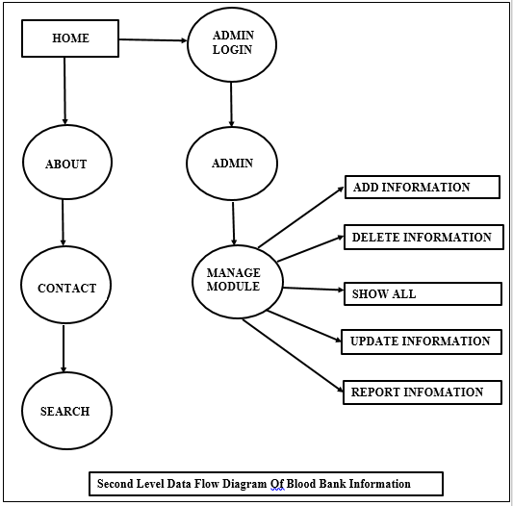

**Figure 5.6: Data Flow Structure of Proposed Architecture**

Data flow diagram level goes one step deeper into parts of level of Blood Bank Information System. It may requires more functionalities of Diary to reach the necessary level details of the Blood Bank information system functioning. First level data flow diagram shows how the Blood Bank information system divided into the sub system. The second level data flow diagram shows more detail structure and the processing and functionality on the Blood Bank information system.

**Chapter 6**

**SYSTEM IMPLEMENTATION**

System implementation refers to the process of putting the designed system into operation. It involves installing the necessary hardware and software components, configuring the system, testing it, and ensuring that it meets the requirements of the stakeholders. The implementation phase is critical in ensuring the success of the system as it is where the system is put into practical use. The implementation plan should be well thought out and include all the necessary steps to ensure a smooth transition from the old system to the new one. It is also important to have a comprehensive training plan to ensure that the users are familiar with the new system and can use it effectively. Finally, proper documentation of the new system should be provided to enable future maintenance and upgrades.

**6.1 SYSTEM CONFIGURATION & ENVIRONMENT:**

The Blood Bank Information System is developed using Visual Basic 6.0 as the front-end programming language and Microsoft Access as the database management system. The system runs on a Windows operating system and requires certain hardware and software configurations.

*Hardware Requirements:*

The hardware requirements for running the Blood Bank Information System include a computer with a minimum of 2GB RAM, a 2GHz processor or higher, and a hard disk with at least 50 MB of free space. Additionally, a printer may also be required for printing reports and documents.

*Software Requirements:*

The software requirements for running the system include a Windows operating system such as Windows XP, Windows 7, Windows 8, or Windows 10. Additionally, Microsoft Access Database Engine is also required to be installed on the computer.

*All About Vb & Ms Access:*

Visual Basic 6.0 is an event-driven programming language that is used to create Windows applications. It provides a graphical user interface that allows developers to create user-friendly applications easily. It also includes features such as drag and drop controls, auto-complete, and syntax highlighting that make programming more efficient.

Microsoft Access is a relational database management system that is used to store and manage data. It provides a graphical user interface for creating tables, queries, forms, and reports. It also includes features such as data validation, indexing, and security that ensure data integrity and confidentiality.

*Vb Installation Steps:*

To install Visual Basic 6.0 on a Windows computer, the following steps can be followed:

1. Insert the Visual Basic installation CD into the CD-ROM drive.
2. Double-click on the setup.exe file to start the installation process.
3. Follow the instructions provided by the installation wizard.
4. Select the components that need to be installed.
5. Choose the installation directory and click on the Install button to start the installation.
6. Once the installation is complete, restart the computer.

In addition to the installation of Visual Basic, Microsoft Access Database Engine can be installed by downloading and installing the appropriate version from the Microsoft website.

**6.2 SYSTEM EXECUTION DETAILS:**

System execution details refer to the actual implementation and deployment of the blood bank information system. This involves the installation of the system on the designated hardware and the configuration of the software components to ensure that they work correctly. The execution also involves the testing and debugging of the system to ensure that it meets the requirements and specifications outlined in the project. This phase requires collaboration between the development team, system users, and stakeholders to ensure that all system components are working as expected. Additionally, documentation and training materials are created to assist users in using the system. During the execution phase, it is crucial to have a well-planned implementation plan to ensure a successful deployment of the system.

*Step 1:* Here the project starts and the very first module of the blood bank information system is the Admin Login module as per given below. Admin Login in the module the admin is allows to enter the username and password to navigate to the admin dashboard.

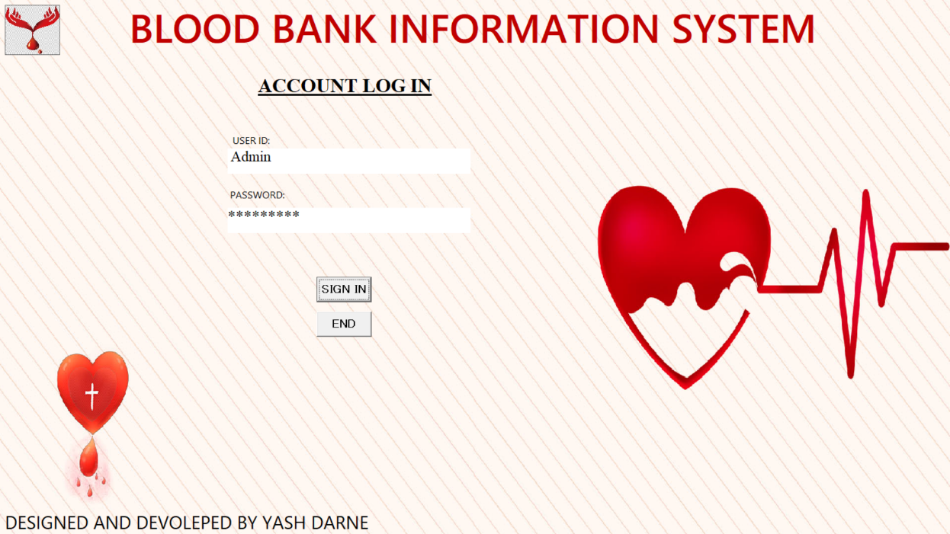

**Figure 6.2 (a): Output 1-Screenshot of Login Form.**

*Step 2:* The second step of the executed project is as the Home module. The home module use to navigate to other modules.

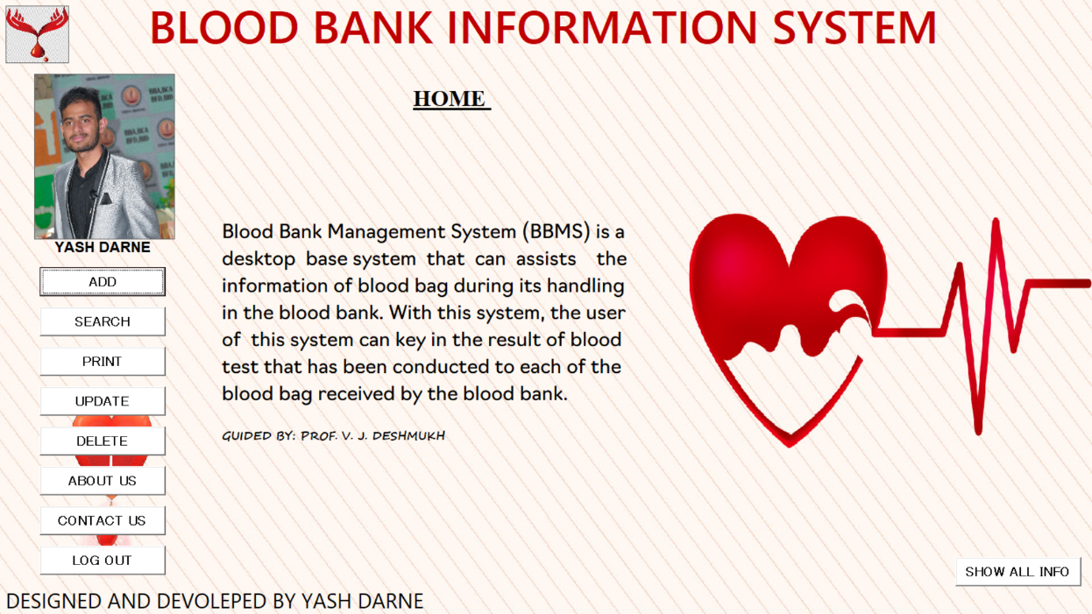

**Figure 6.2 (b): Output 2-Screenshot of Home Form.**

*Step 3:*Is a sub modules of the admin home module is this module first navigation where admin can insert the information as per given below.

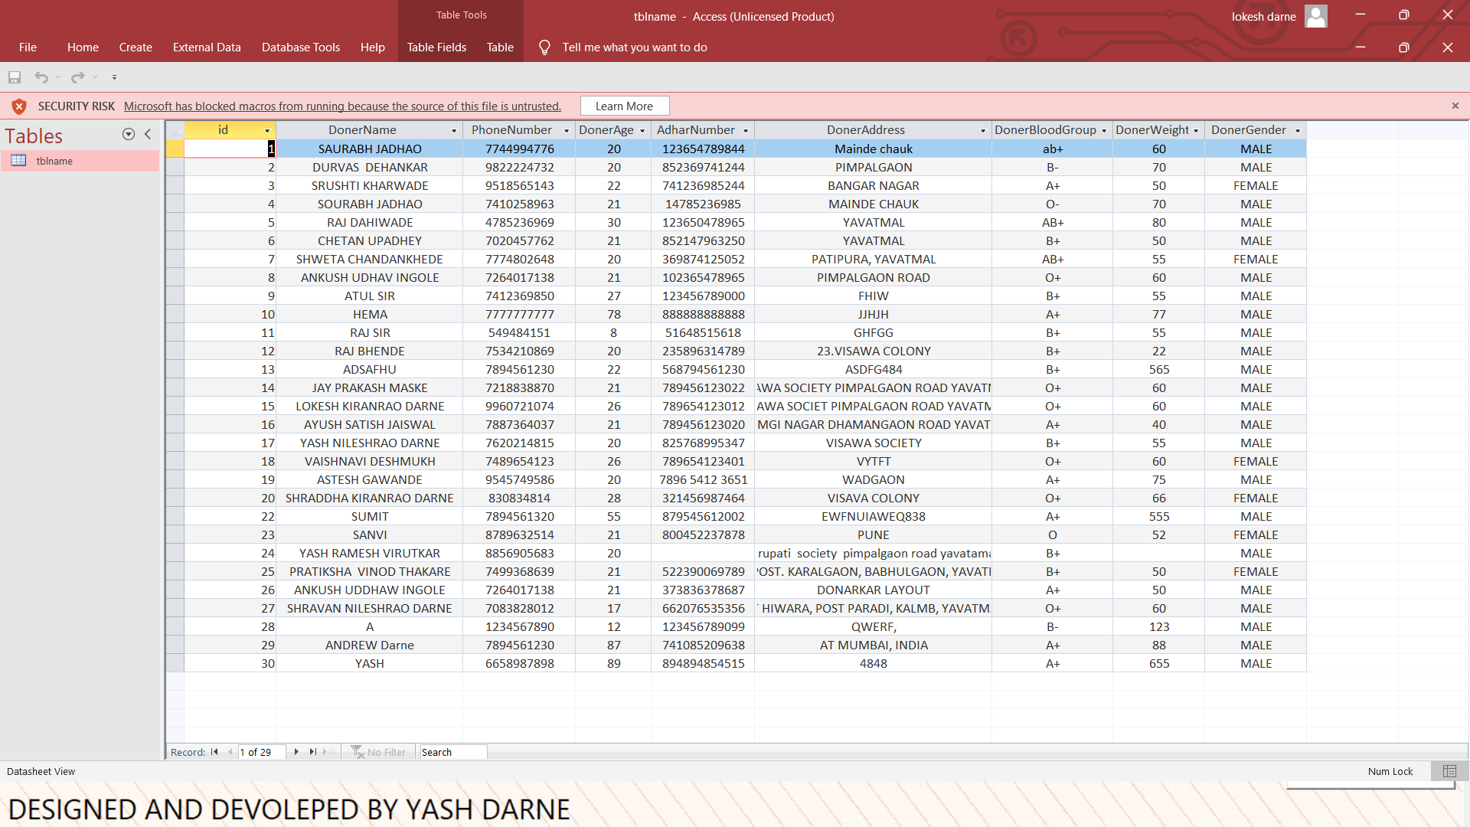

**Figure 6.2 (c): Output 3-Screenshot of (Ms-Access) Database Before Adding Data.**

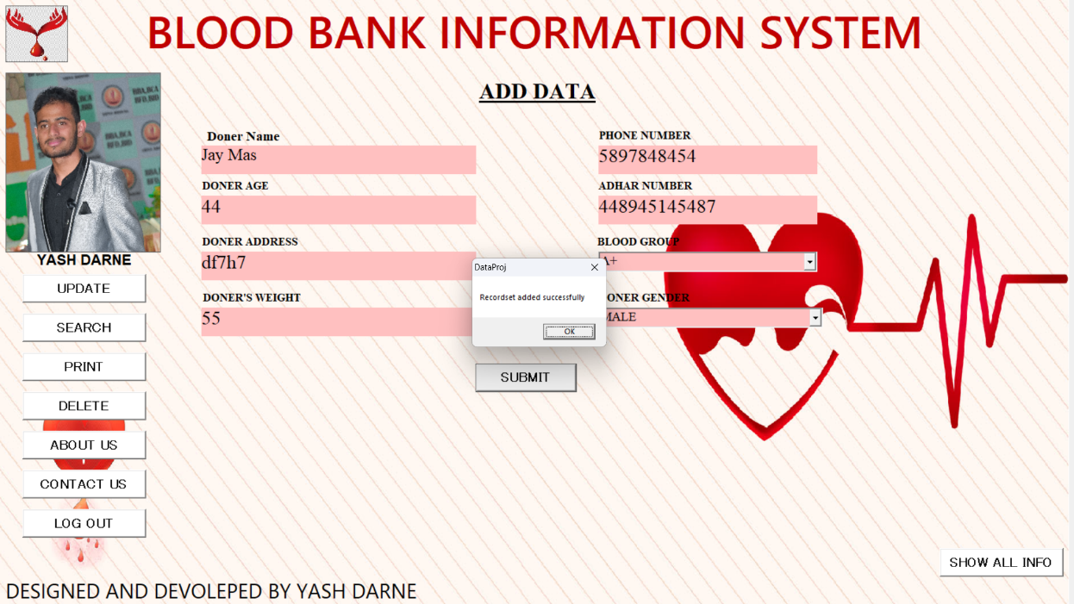

**Figure 6.2 (d): Output 3-Screenshot of Add Data Form.**



**Figure 6.2 (e): Output 3-Screenshot of (Ms-Access) Database After Adding Data.**

In the add information module admin can insert the information as needed and mentions in on the module then the “BACK” command button is used to go back to the admin home to perform other activities.

*Step 4:*In this step the admin is use to navigate to other module of admin dashboard. This module is used to Search information which is previously entered and need to fetch. Search module is simply use the fetch information from the database. Then back command button is used to go back on the home module

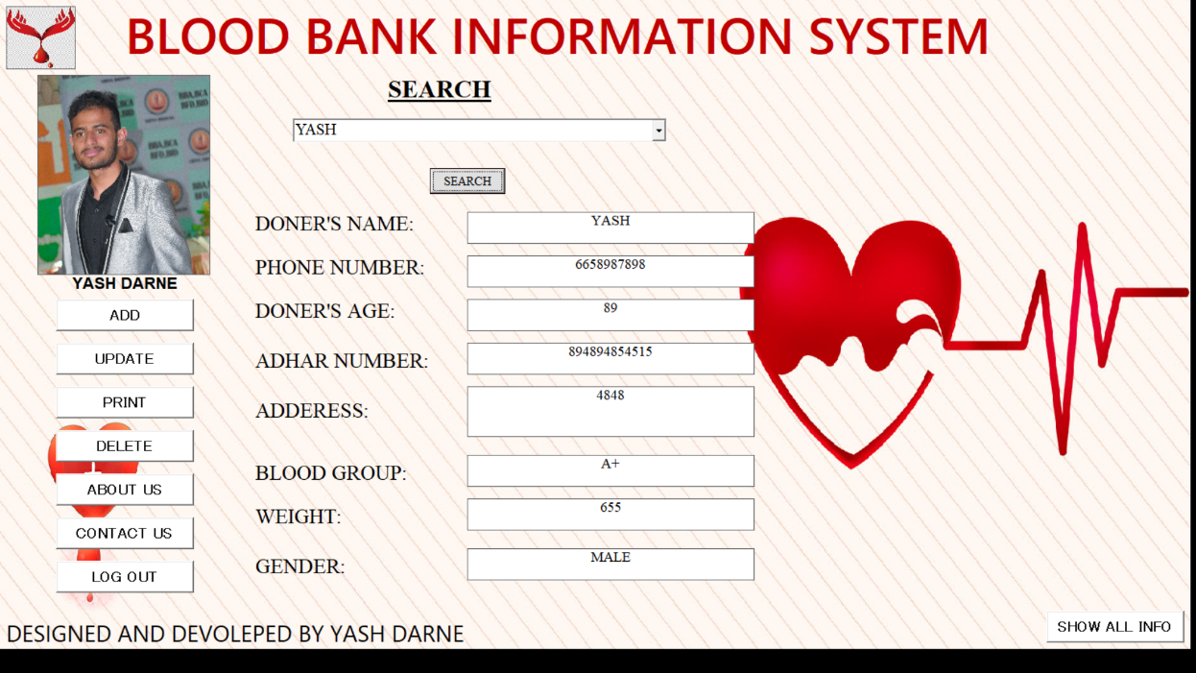

**Figure 6.2 (f): Output 4-Screenshot of Search Form.**

*Step 5:*In this step the admin is use to navigate to other module of admin dashboard. This module is used to update information which is previously entered and need to update. Update module is simply use the update information is the database. Then back command button is used to go back on the home module.

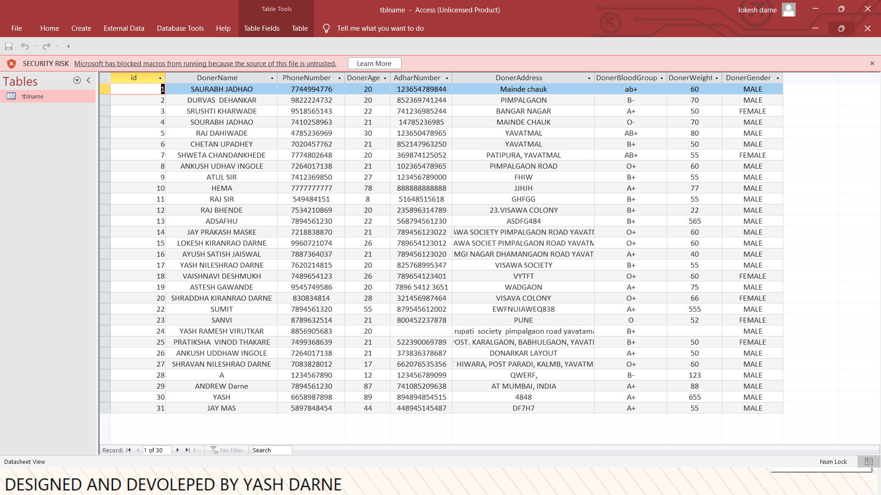

**Figure 6.2 (g): Screenshot of (Ms-Access) Database Before Updating Data.**

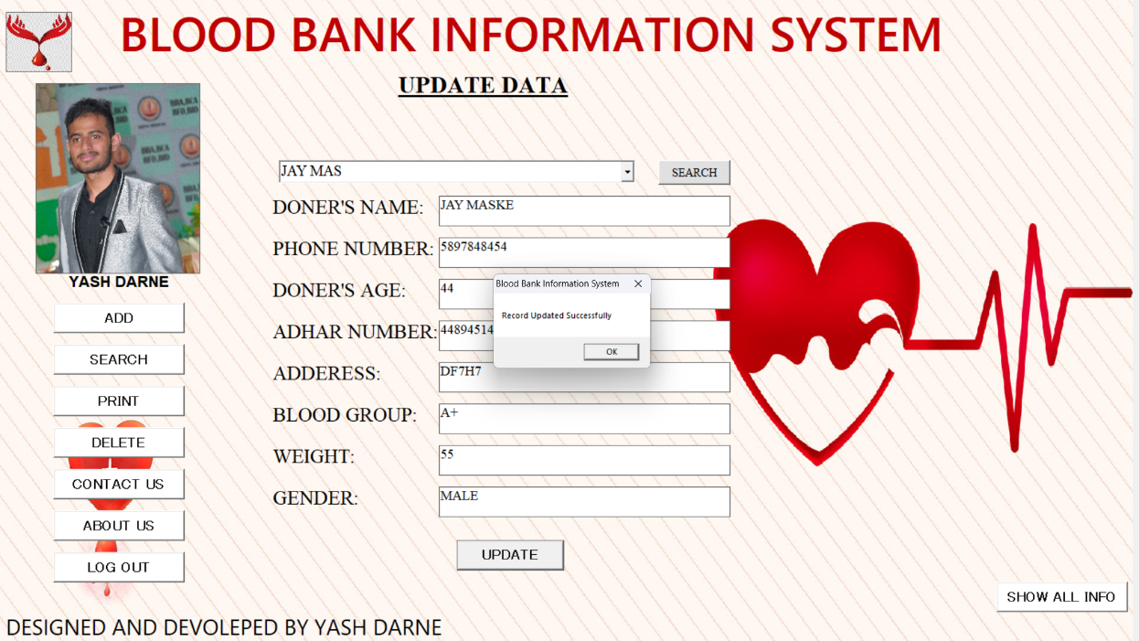

**Figure 6.2 (h): Output 5-Screenshot of Update Form.**

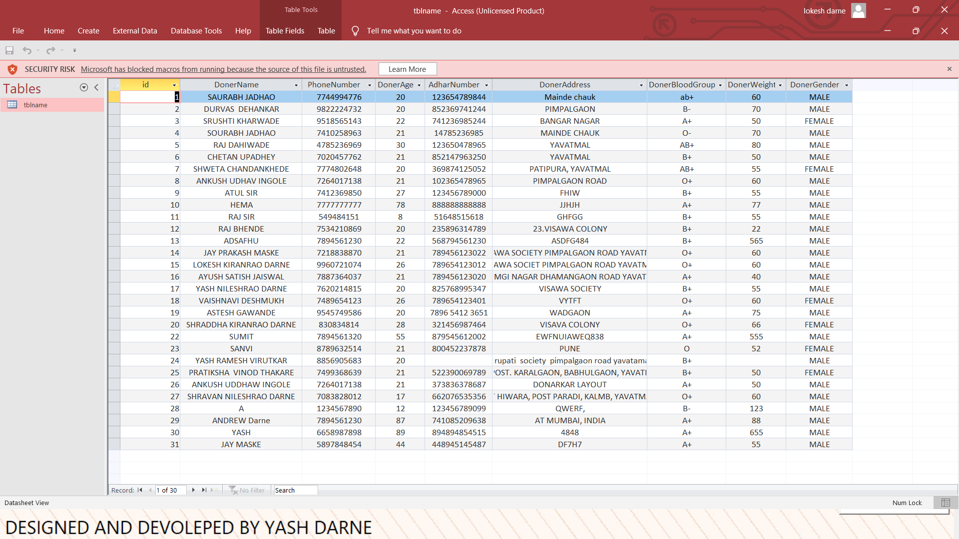

**Figure 6.2 (i): Screenshot of (Ms-Access) Database After Updating Data**

*Step 6:*Is used to delete the selected records which is as per the admin needs and get deleted by just a single click. Then back command button is used to go back on the dashboard module.



**Figure 6.2 (j): Screenshot of (Ms-Access) Database Before Deleting Data.**

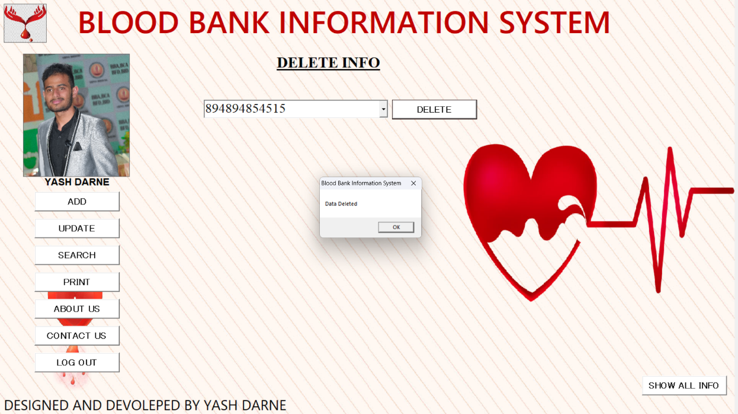

**Figure 6.2 (k): Output 6-Screenshot of Delete Form.**

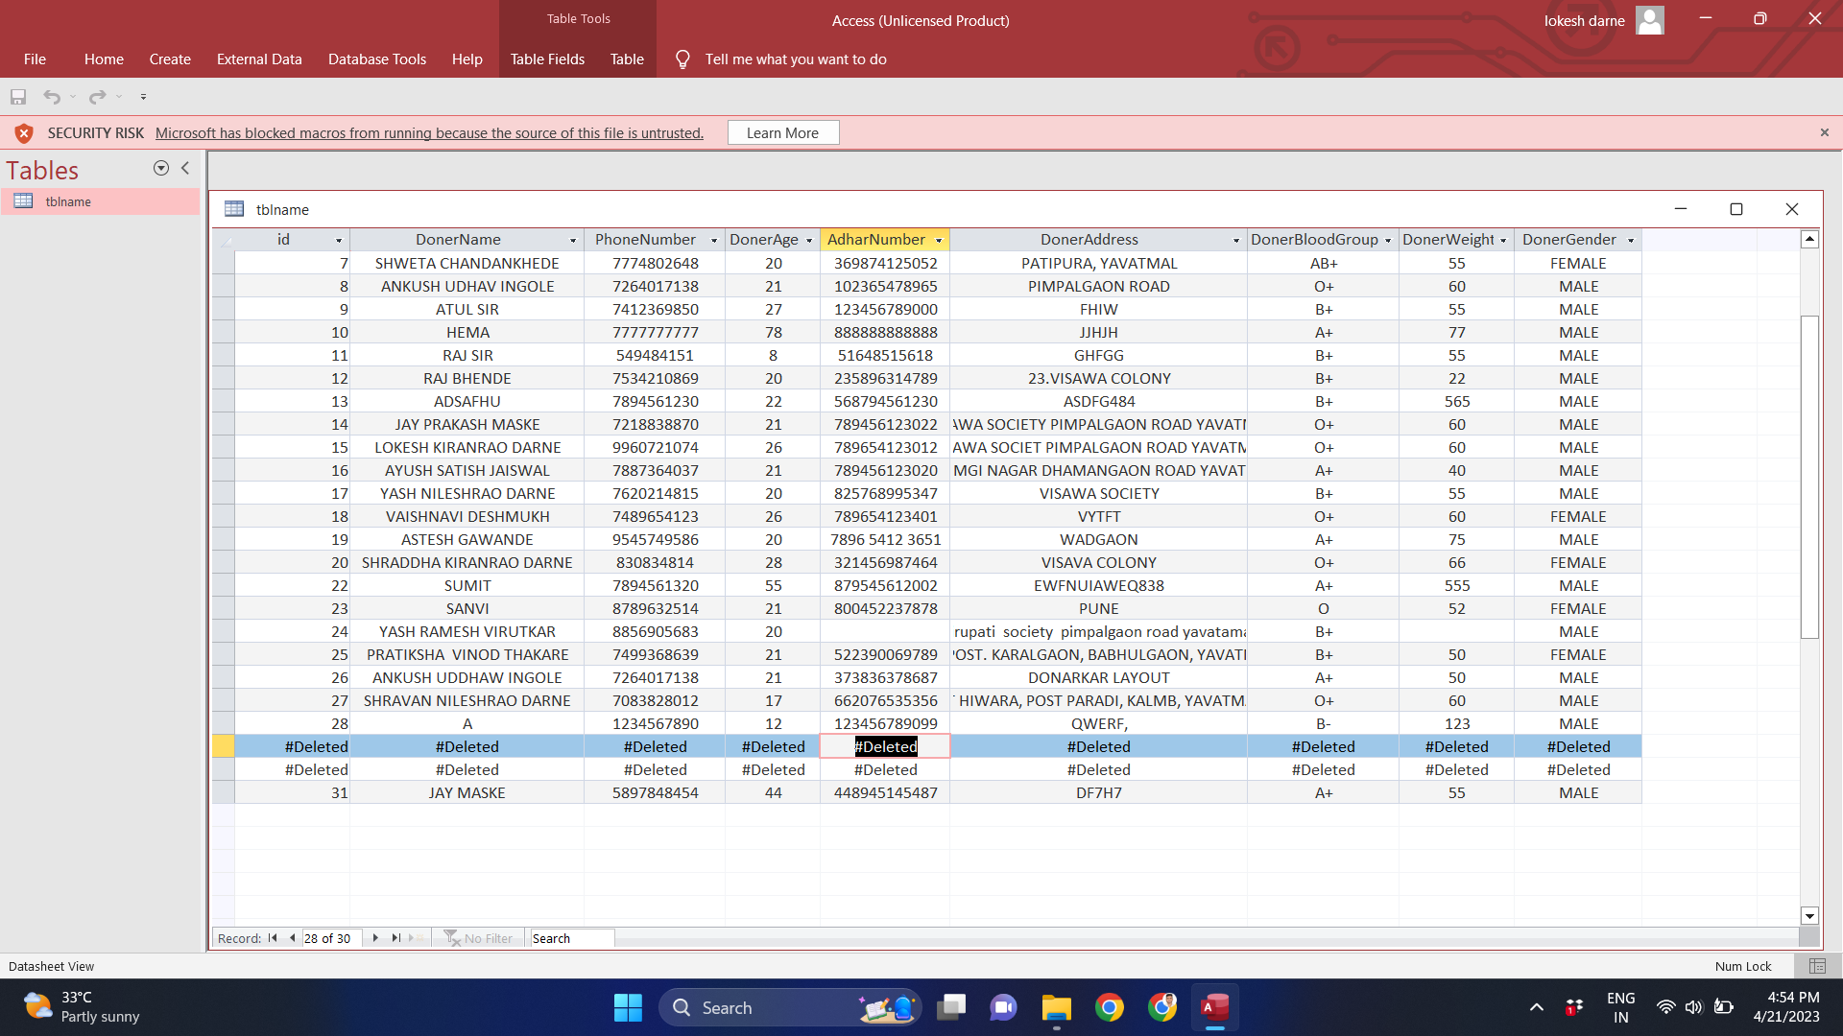

**Figure 6.2 (l): Screenshot of (Ms-Access) Database After Deleting data.**

*Step 7:* Is another sub module of the admin dashboard in this module admin is used to allow to fetch all the record in the database by just single click. Then back command button is used to go back on the dashboard module.

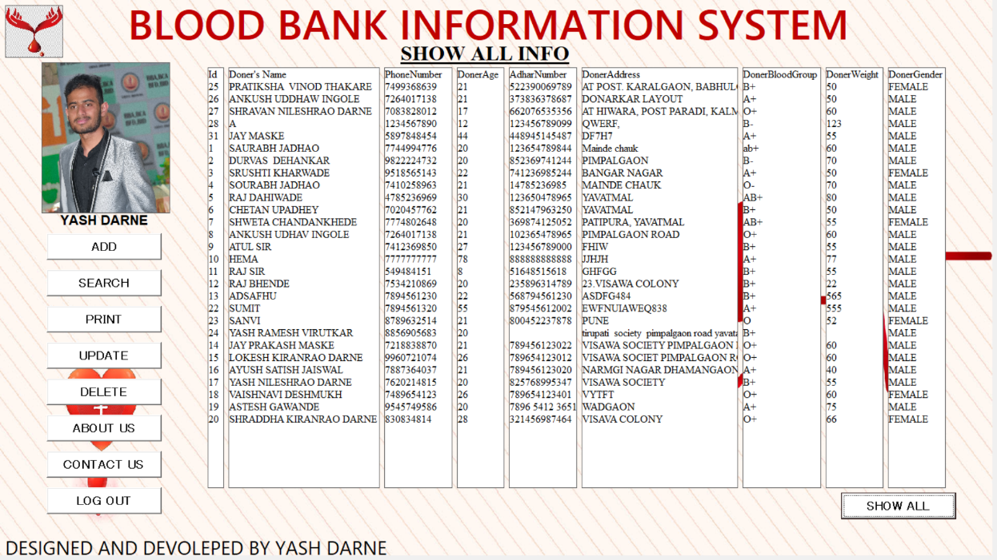

**Figure 6.2 (m): Output 7-Screenshot of Show All Info Form.**

*Step 8:*This module is used to gives a report of the records and the copy of the information and show the data and use to take the prints of the data. Then back command button is used to go back on the dashboard module. In the last admin can use to navigate to the admin login page by using the command button named as “LOGOUT”.

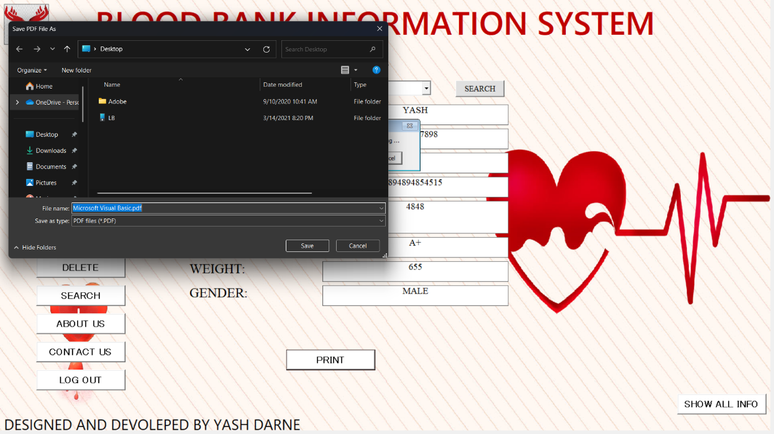

**Figure 6.2 (n): Output 8-Screenshot of Print Report Form.**

*Step 9:*In this step admin navigate to the about module. In this module about module simply provide the information about the nursery information system. The executed look of the module is as pre given below.

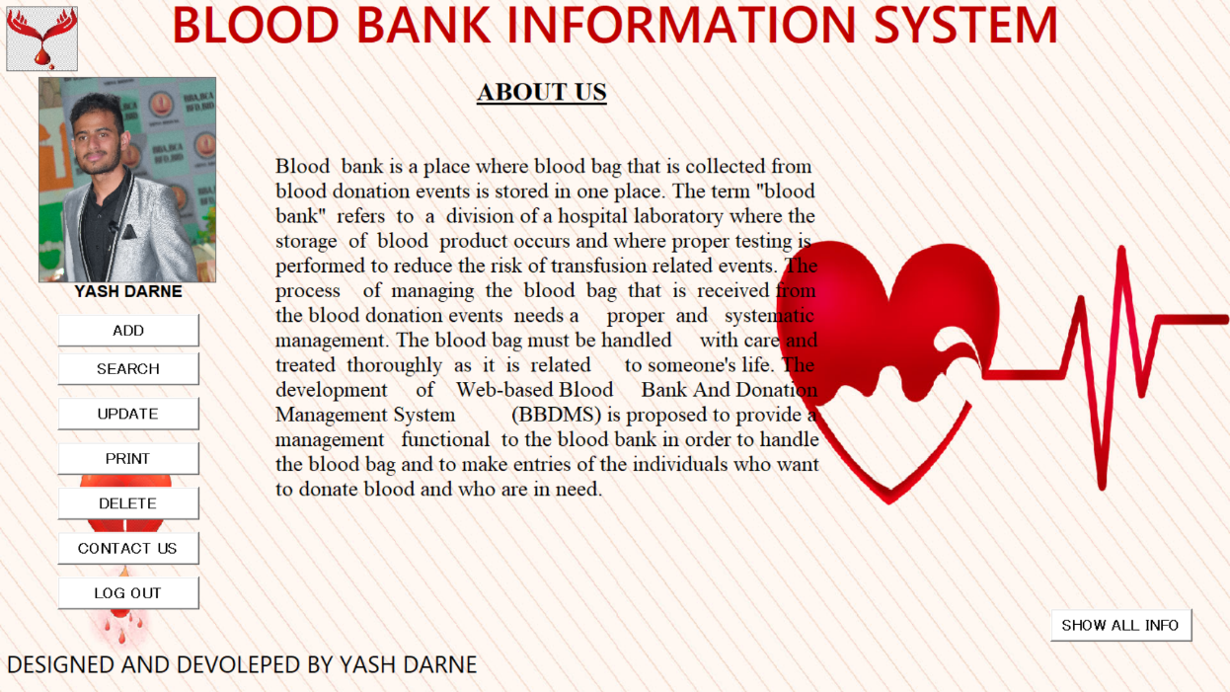

**Figure 6.2 (o): Output 9-Screenshot of About Us Form.**

*Step 10:*In this step admin can navigate to the contact module where the module provide the communication platforms where the contact number and email Id is provided as per given below.

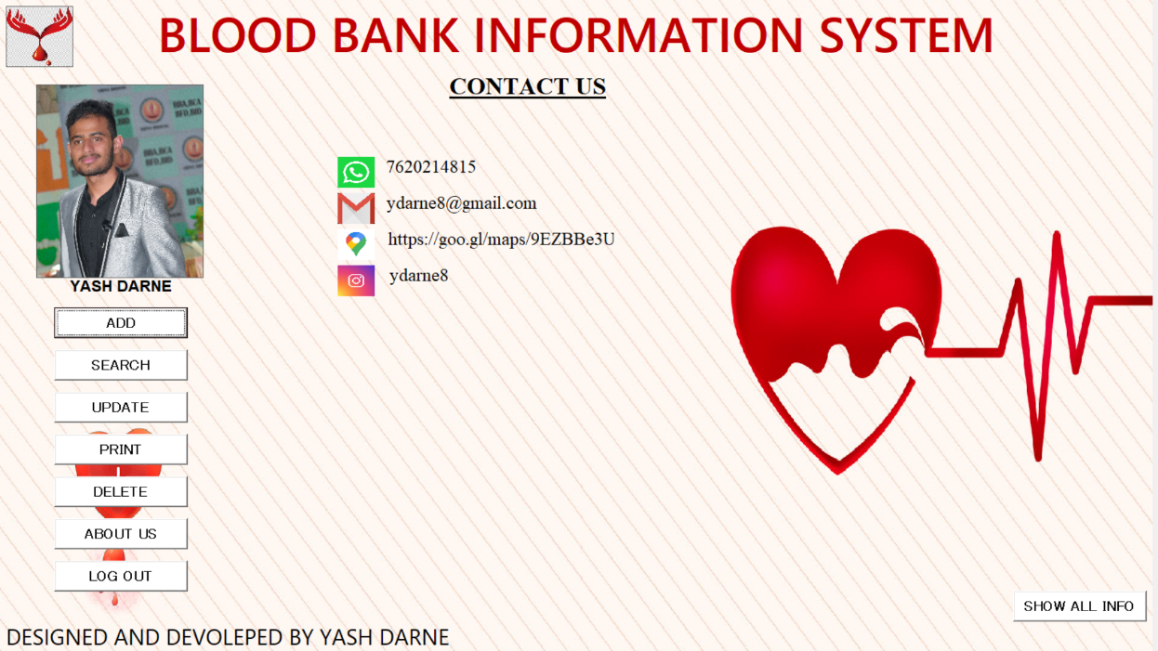

**Figure 6.2 (p): Output 10-Screenshot of Contact Us Form.**

**Chapter 7**

**CONCLUSION**

**7.1 CONCLUSION**

In conclusion, the development of a Blood Bank Information System using Visual Basic 6.0 and MS Access database technology is a crucial project that can greatly benefit the healthcare industry. This system is designed to automate the blood donation process, ensure that blood supply is sufficient, and maintain a database of donors, recipients, and blood inventory.

Through the system analysis and design process, we have identified the requirements and objectives of the system, as well as the hardware and software components necessary for its implementation.

One of the main objectives of the system is to provide a more efficient and accurate blood donation process. The system ensures that all donors are screened before donation and that their medical history is properly recorded. This way, only safe blood is accepted, and the risk of transmission of diseases is minimized. Additionally, the system allows donors to schedule their donation appointments, making the process more convenient and organized.

Another objective of the system is to maintain a well-organized and up-to-date database of blood inventory, donors, and recipients. This way, blood supply can be effectively managed, and the availability of blood can be determined in real-time. The system also provides a quick and easy way to search for donor and recipient information, and to update their records as necessary.

Overall, the Blood Bank Information System can greatly benefit the healthcare industry, and the implementation of this system can contribute to better blood management, improved patient care, and ultimately, saved lives.

**Chapter 8**

**FUTURE SCOPE**

**8.1 FUTURE SCOPE**

The Blood Bank Information System project has the potential for further development and implementation. Some of the future scopes for this project are as follows:

1. *Mobile Application:* The Blood Bank Information System can be developed as a mobile application to make it more accessible to users. The mobile application can have features like blood donation camps, appointment booking for blood donation, and notifications for blood donation requirements.
2. *Integration with Hospital Information System:* The Blood Bank Information System can be integrated with the Hospital Information System to make it more effective. This integration can help the hospital staff to access blood bank data easily and quickly. This will also help to track the blood donation history of the patient.
3. *Cloud-based System:* The Blood Bank Information System can be developed as a cloud-based system to enable remote access. This will allow blood banks in different locations to access the data and communicate with each other. This will also help to maintain the records of blood donors and recipients in a centralized location.
4. *Donor Management System:* The Blood Bank Information System can be further developed to include a donor management system. This system can be used to maintain records of donors, their contact information, and donation history. This will help to identify regular donors and encourage them to continue donating blood.
5. *Machine Learning Integration:* The Blood Bank Information System can be integrated with machine learning algorithms to predict the demand for blood in different regions. This can help blood banks to prepare in advance and ensure that there is an adequate supply of blood for emergencies.
6. *Blockchain Technology:* The Blood Bank Information System can also be developed using blockchain technology. This will provide an immutable record of blood donation and transfusion, which will increase transparency and trust in the system.

In conclusion, the Blood Bank Information System project has enormous potential for further development and implementation. The future scopes mentioned above are just a few examples of how this system can be improved and made more effective. The integration of new technologies and features will help to ensure that the system continues to meet the needs of blood banks and hospitals in the future.

**REFERENCES**

1] Safe blood and blood products. Module 1: Safe blood donation. Geneva: World Health Organization; 2002. [17 August 2012]. http://www​.who.int/bloodsafety​/transfusion_services​/bts_learningmaterials​/en/index.html.

2] Blood donor selection. Guidelines on assessing donor suitability for blood donation. Annex 3. Geneva: World Health Organization; 2012. [17 August 2012]. http://www​.who.int/bloodsafety​/voluntary_donation​/blood_donor​_selection_counselling/en/ [PubMed]

3] Aide-mémoire. Blood safety. Geneva: World Health Organization; 2002. [17 August 2012]. http://www​.who.int/bloodsafety​/publications​/who_bct_02_03/en/index.html.

4] WHO/IFRC. Towards 100% voluntary blood donation: A global framework for action. Geneva: World Health Organization; 2010. [17 August 2012]. http://www​.who.int/bloodsafety​/publications​/9789241599696/en/ [PubMed]

5] The Melbourne Declaration on 100% voluntary non-remunerated donation of blood and blood components. Geneva: World Health Organization; 2009. [17 August 2012]. http://www​.who.int/worldblooddonorday​/Melbourne​_Declaration_VNRBD_2009.pdf.

6] WHO/CDC/IFRC. Blood donor counselling: Implementation guidelines. Geneva: World Health Organization; 2012. [17 August 2012]. http://www​.who.int/bloodsafety​/voluntary_donation​/blood_donor​_selection_counselling/en/ [PubMed]

7] Screening donated blood for transfusion-transmissible infections. Geneva: World Health Organization; 2010. [17 August 2012]. http://www​.who.int/bloodsafety​/publications​/bts_screendondbloodtransf/en/index​.html. [PubMed]

8] Reiss RF. Blood donor well-being: a primary responsibility of blood collection agencies. Annals of Clinical & Laboratory Science. 2011;41(1):3–7. [PubMed]

9] Global Database on Blood Safety. Summary report 2011. Geneva: World Health Organization; 2011. [22 August 2012]. http://www​.who.int/entity​/bloodsafety/global_database​/GDBS_Summary_Report_2011​.pdf.

10] Boulton F. Evidence-based criteria for the care and selection of blood donors, with some comments on the relationship to blood supply and emphasis on the management of donation-induced iron depletion. Transfusion Medicine. 2008;18:13–27. [PubMed]

11] Eder A, et al. Selection criteria to protect the blood donor in North America and Europe: past (dogma), present (evidence), and future (hemovigilance). Transfusion Medicine Reviews. 2009;23(3):205–220. [PubMed]

12] Moreno J. “Creeping precautionism” and the blood supply. Transfusion. 2003;43:840–842. [PubMed]

13] Farrugia A. The mantra of blood safety: time for a new tune? Vox Sanguinis. 2004;86:1–7. [PubMed]

14] Fifty-Eighth World Health Assembly. Resolution WHA58.13: Blood safety: proposal to establish World Blood Donor Day. Geneva: World Health Organization; 2005. [17 August 2012]. http://www​.who.int/bloodsafety​/resolutions/en/index.html & http://www​.who.int/entity​/bloodsafety/BTS​_ResolutionsAdopted.pdf.

15] Sixty-Third World Health Assembly. Resolution WHA63.12: Availability, safety and quality of blood products. Geneva: World Health Organization; 2010. [17 August 2012]. http://www​.who.int/bloodsafety​/resolutions/en/index.html & http://www​.who.int/entity​/bloodsafety/BTS​_ResolutionsAdopted.pdf.

16] WHO handbook for guideline development. Geneva: World Health Organization; 2012. [10 August 2012]. http://apps​.who.int/iris​/bitstream/10665​/75146/1/9789241548441_eng.pdf.

17] WHO/CDC. Donor selection and counselling. Report of inter-regional workshop on blood donor selection and donor counselling for priority countries in the African and Eastern Mediterranean regions. Geneva: World Health Organization; Jun, 2011. [17 August 2012]. 2011. (http://www​.who.int/entity​/bloodsafety/WHO-CDC​_ReportDonorSelectionCounsellingWorkshopKenya.2011.pdf.

18] Heddle NM. Evidence-based decision making in transfusion medicine. Vox Sanguinis. 2006;91(3):214–220. [PubMed]

19] Vamvakas EC. Evidence-based practice of transfusion medicine: is it possible and what do the words mean? Transfusion Medicine Reviews. 2004;18(4):267–278. [PubMed]

20] Franklin IM. Is there a right to donate blood? Patient rights; donor responsibilities. Transfusion Medicine. 2007;17(3):161–168. [PubMed]

21.

Brooks JP. The rights of blood recipients should supersede any asserted rights of blood donors. Vox Sanguinis. 2004;87(4):280–286. [PubMed]

22] Dodd RY. Current estimates of transfusion safety worldwide. Developments in Biological Standardization (Basel). 2005;120:3–10. [PubMed]

23] Seifried E, et al. How much blood is needed? Vox Sanguinis. 2011;100:10–21. [PubMed]

24] Custer B, et al. Community blood supply model: development of a new model to assess the safety, sufficiency, and cost of the blood supply. Medical Decision Making. 2005;25(5):571–582. [PubMed]

25] Donor selection in case of pandemic situations. Geneva: World Health Organization; 2007. [10 August 2012]. http://www​.who.int/bloodproducts​/brn/DonorSelectionincaseofPandemicSituations​.pdf.

26] Crookston KP, Wilkinson SL, Simon TL. Recruitment and screening of donors and the collection, processing and testing of blood. In: Simon TL, et al., editors. Rossi's Principles of transfusion medicine. 4th edition. Oxford: Wiley-Blackwell; 2009.

27] Busch MP. Retroviruses and blood transfusion: the lessons learnt and challenges ahead. In: Nance SJ, editor. Blood safety: current challenges. Bethesda, MD: AABB; 1992. pp. 1–44.

28] Stigum H, et al. Risk behavior in Norwegian blood donors. Transfusion. 2001;4(12):1480–1485. [PubMed]